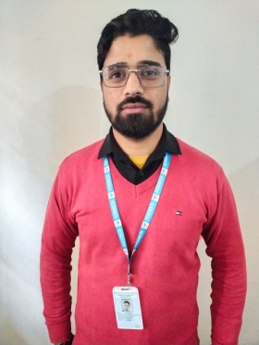

Vinod Dhasmana

Assistant professor in Nimbus School of Education

Area

Primary Area: Education

Secondary Area: Humanities,

Contact: 7895430291

Email: vkd557@gmail.com

Phone: +91-7895430291

Education

• Master of Education, Swami VivekaNand Subharti University Merrut

• Bachelor of Education, Uttrakhand Sanskrit University Haridwar

• Master of Art, Bachelor of Art

Teaching

• Hindi

• Sanskrit

• Language Across the Curriculum

Research Area

Hindi Literature Sanskrit Sahitya

Academic Experience

Faculty Member, Nimbus School of Education, 19 December 2021 onwards.

Professional Experience

Nimbus School of Education

Selected Publications

Shodash Sanskar

Medium of Hindi ,Sanskrit and English Students thinking style and academic achievement